**RIYA INDAP,44**

~file(used to determine the type of file)

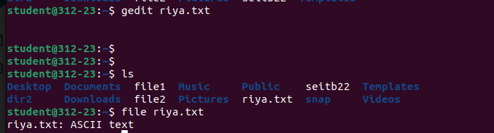



~whereis man(a utility for locating the binary, source, and manual page files for a command)

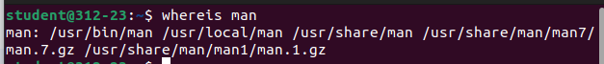

~which man & which gedit(allows users to search the list of paths in the $PATH environment variable and outputs the full path of the command specified as an argument)

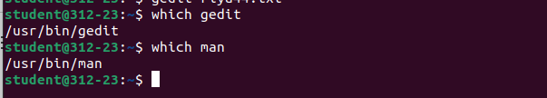

~tar(used to create Archive and extract the Archive files)



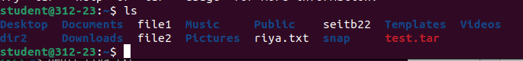

~stat(a powerful tool used to display detailed information about a file or file system)

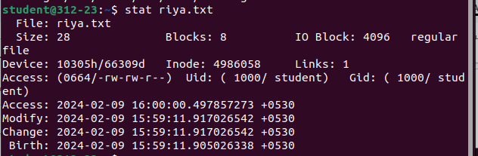

~chmod(protects files and directories from unauthorized access in the filesystem by setting access permissions)

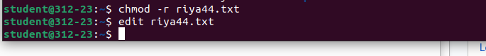

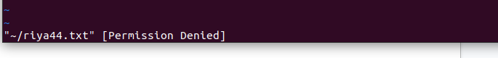

~chmod +r

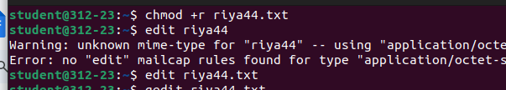

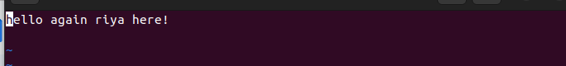

~sudo chown(used to change a file's ownership, directory, or symbolic link for a user or group)

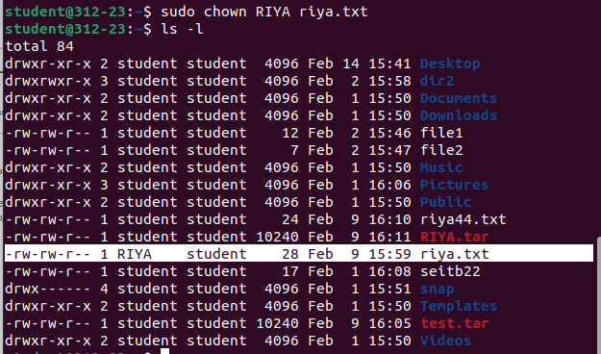

~Sudo chgrp(changes the group of the file or directory specified by the File or Directory parameter to the group specified by the Group parameter)

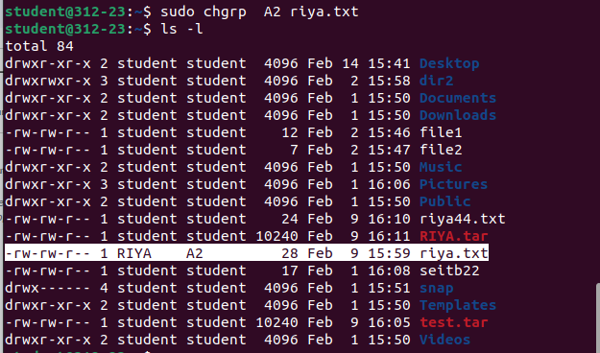

~wc (a command line utility for printing newline, word and byte counts for files.)



~split(is used to split large files into smaller files.)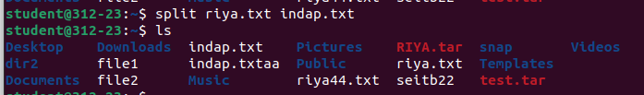

~cmp(compares files designated by the File1 and File2 parameters and writes the results to standard output)



~diff(diff is a command-line utility that allows you to compare two files line by line)

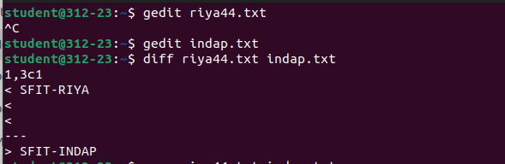

~ls -l(list info about files and directories within system)

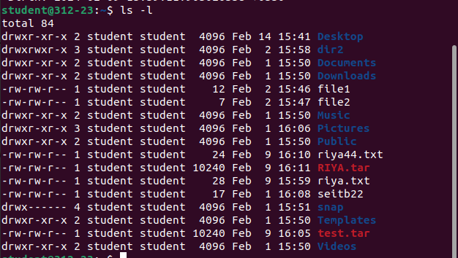

~sudo useradd(used to add user accounts to your system)



~sudo groupadd(tool that facilitates the creation of new groups effortlessly)



~comm(compare two sorted files line by line and write to standard output;)



~type pwd(writes to standard output the full path name of your current directory)



~gzip(Each single file is compressed into a single file. The compressed file consists of a GNU zip header and deflated data.)

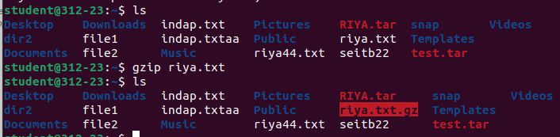

~gunzip(gunzip command is used to compress or expand a file or a list of files in Linux.)

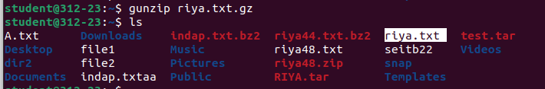

~bzip2(handling multiple files, encryption, and archive-splitting)

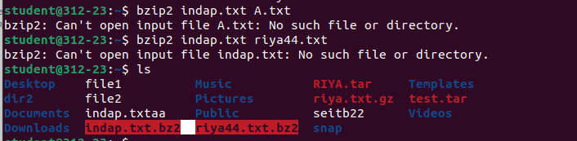

~bzip2 -z/-d

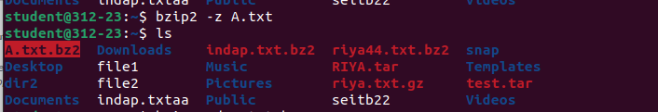

~zip( used to compress files and packaging them into a single .zip archive)

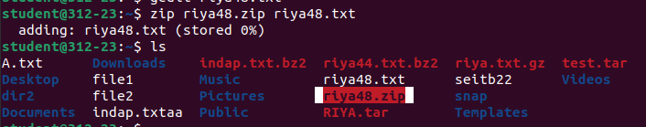

~unzip(tool for extracting files from ZIP archives)

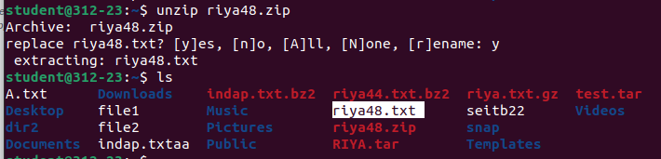

~locate(locate command is a Unix utility used for quickly finding files and directories.)

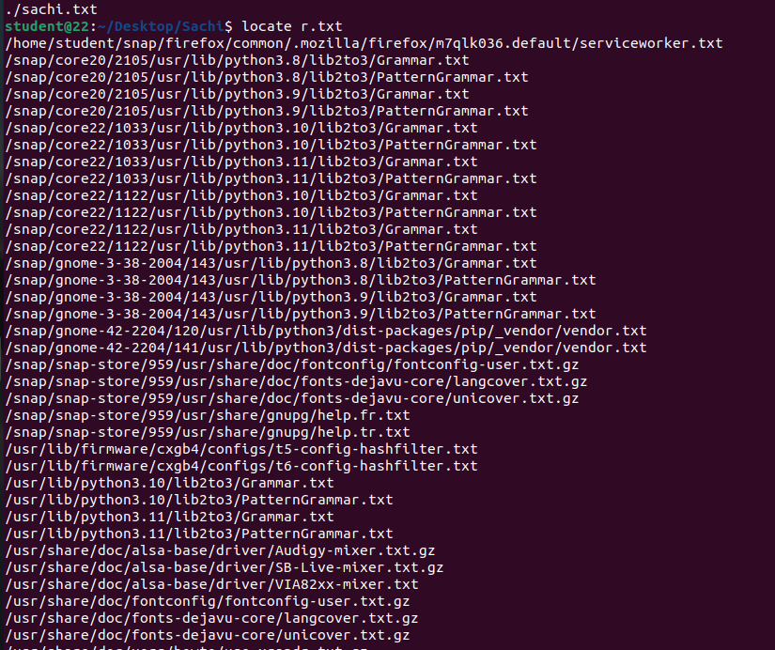

~find(begin looking in the starting directory you specify and proceed to search through all accessible subdirectories)

